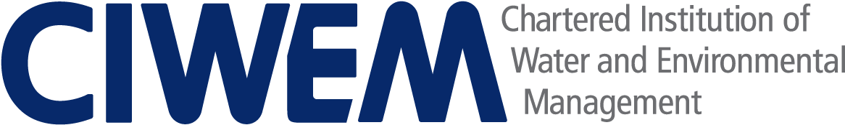

Sponsored by

Young Environmentalist of the Year

APPLICATION FORM

APPLICANT INFORMATION

NAME

CURRENT ROLE

ORGANISATION

ADDRESS EMAIL ADDRESS

CONTACT NUMBER

LEVEL OF CIWEM MEMBERSHIP AND MEMBERSHIP NUMBER (IF APPLICABLE)

YEARS OF PROFESSIONAL EXPERIENCE IN THE WATER/ENVIRONMENT SECTOR

LINE MANAGER/BRANCH CONTACT INFORMATION – NB we may contact this person if we feel it is necessary to verify information provided as part of your application.

NAME

ORGANISATION

EMAIL ADDRESS

Please outline your reasons for entering the competition. Briefly highlight your experience in the water/environment sector, relevant qualifications and any professional registrations in your answer.

Please outline any work you have conducted outside of your normal remit which contributes to environmental awareness and understanding. This can be paid or unpaid, as an addition to your day job or something you do in your own time.

How does your application align with CIWEM’s vision of creating a safer more sustainable world?

Further comments in support of your application

APPLICATION

Please return the completed Application Form with an outline CV and the Equal Opportunities Form to awards@ciwem.org with ‘Young Environmentalist of the Year Award’ in the subject heading.

