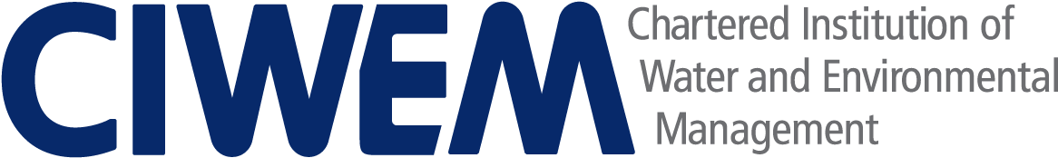

in partnership with
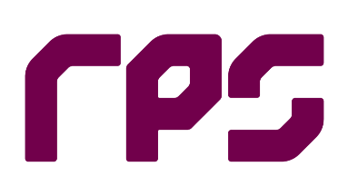

The Margetts Bursary
Urban Drainage Engineering

APPLICATION FORM

APPLICANT INFORMATION

NAME

ADDRESS EMAIL ADDRESS

CONTACT NUMBER

CIWEM MEMBERSHIP NUMBER (IF APPLICABLE)

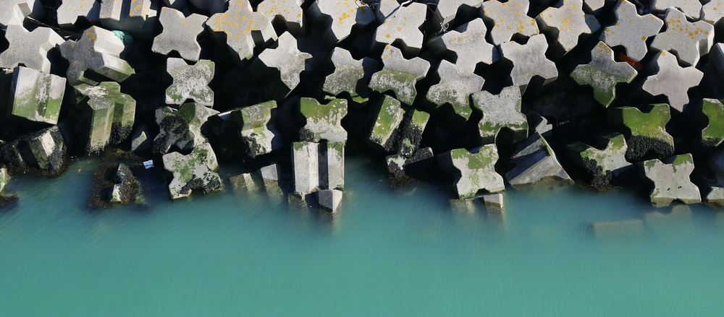

APPLICATION STATEMENT

In a statement of less than a page, explain the following:

- What research, project, equipment, studies etc you would use your bursary for?
- How this would tie in with the vision that Jamie Margetts had for sustainable management of water and the environment, which he strived to deliver daily through his role at RPS and his leadership of CIWEM’s Urban Drainage Group?

Please return the completed Application Form with an up-to-date version of your CV, which outlines your previous academic studies and/or current professional activities, and the Equal Opportunities Form to awards@ciwem.org with ‘The Margetts Bursary’ in the subject heading.

